**Personnel Management**

Contents

Scope: 3

Access: 3

General Rules: 4

Features: 5

Personnel Management View 6

Add Personnel 9

Export Function 18

Merge Function 21

Editing Personnel 24

Removing Personnel from the lists 28

Allocating Bulk Staff to Campaigns 31

Creating a New Campaign 32

Bulk staff allocations between existing campaigns 33

Bulk allocations using a .csv import 38

|  |  |  |  |
| --- | --- | --- | --- |
| **Revision** | **Date** | **Name** | **Description** |
| 1.0 | 2021/01/01 | L Petersen | Initial doc. |
| 1.1 | 2021/04/16 | L Petersen | Added Bulk Staff Allocations |
| 1.2 | 2021/06/23 | L Petersen | Import .csv Bulk Allocations |
|  |  |  |  |
|  |  |  |  |
|  |  |  |  |
|  |  |  |  |

# Scope:

Create a table to capture (role) hierarchy information, that will be used to populate the agent, team leader and manager lists.

This input table will generate a unique id, that will allow for changes (spelling, ect) to be made without disrupting the data already captured.

The employee id is to better identify and control the person lists for the client and allow for name changes and updates.

It also includes an email and employee id input function.

The email address is for future development that will allow the agent to give feedback via email to the app.

# Access:

(until new admin permissions are implemented)

Dev Admin

System Admin

Client Admin

IA Admin

View:

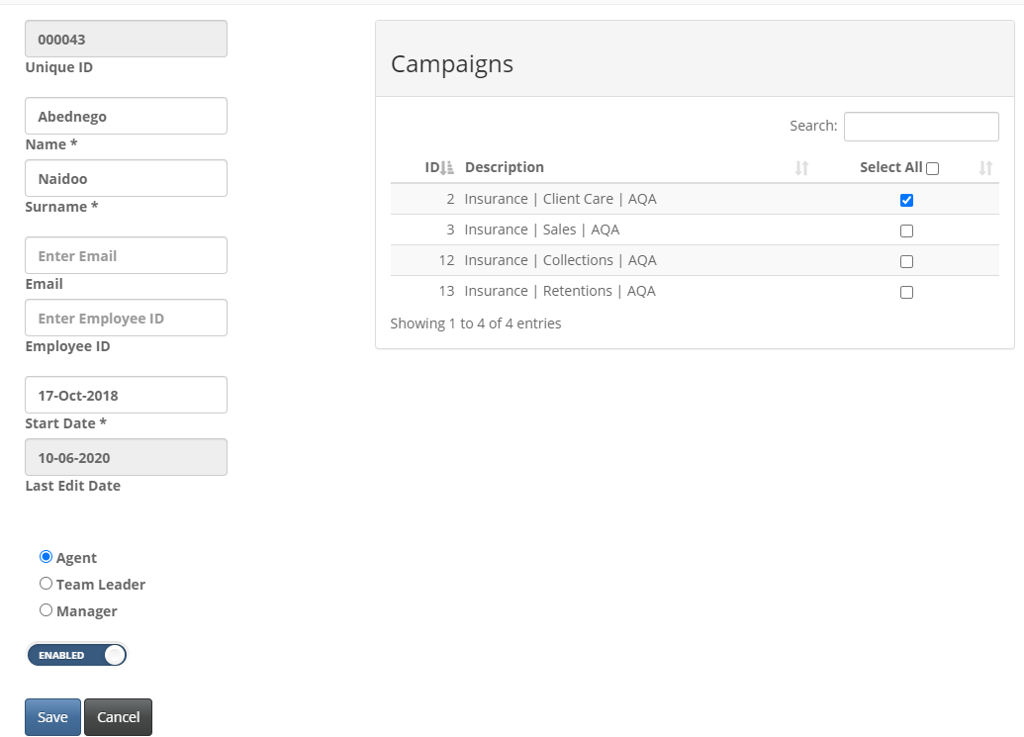

# General Rules:

* Input fields ie. Name, Surname, Email and Employee ID are limited to 50 characters.
* All special characters are allowed in the above fields, excluding quotations characters.
* The 26 letters of the alphabet are allowed in the name and surname fields. Also included are accents such as â, è, î, ö or ú.
* Numbers are allowed in the name and surname field. We do not recommend using numbers when creating users.
* Only one role per user, per customer (db) can be assigned per person.
* The systems will only allow for one unique Name Surname combination, ie you can’t have two or more people named Jo Soap. Such names should be individualized with a middle name / initial / nickname.

# Features:

* A unique id will be allocated to each new person automatically
* Email and Employee id are non-compulsory
* Person can be allocated (assigned) to multiple campaigns per customer (db)
* Person can be disabled from list (which will remove them from their respective list, but not reporting.)
* Where name changes were done in the past, resulting in data being split, agent names can now be merged and combining the data.

Future enhancements to be spec:

* Allowing the client access to decide whether non-compulsory fields need to be made compulsory. (Per customer / db)
* Enabling the agent to add feedback via an email loop

# Personnel Management View

The Personnel Management will be accessible via the Management Menu.

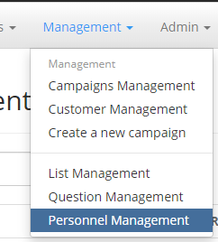

There are 2 views available as well a menu.

Views:

1. Personnel – shows indiviual personnel details
2. Campaigns – shows campaign details

Menu:

1. Customer – Will display all databases linked to the clients’ app
2. Add Personnel – add single individuals’ data
3. Refresh – Reloads page
4. Import – this is for bulk staff imports into a specific campaign
5. Export – allows for exporting of staff data to a .csv file from a specific campaign
6. Merge – allows for the data for two separate individuals to be consolidated. This is to resolve cases resulting from the previous list management tool. Cases resulting from names changes or spelling errors.



Personnel View: Shows the basic detail per indiviual personnel in a table format including:

1. Name
2. Surname
3. Email
4. Employee ID
5. Role (Agent, Team Leader or Manager)
6. Active (Enabled or Not)

Clicking on either the name or surname (blue script) or selecting the pencil on the right hand side of the table will allow you to edit the selected person.

There is also a delect icon on the right hand side of the table, however you will only be able to delete a person if there are no captures associated to that person.

If there are captures you can remove the person from the lists by disabling that person.

All colomns are sortable using the icon located on the right hand site of the headings on the table.

There is a Search option in the top right hand corner to narrow the entries in the table.

There is also a Show option in the top left hand corner to increase the entries on the table.

This is limited to a selection of 10, 20, 50 or 100 entries.



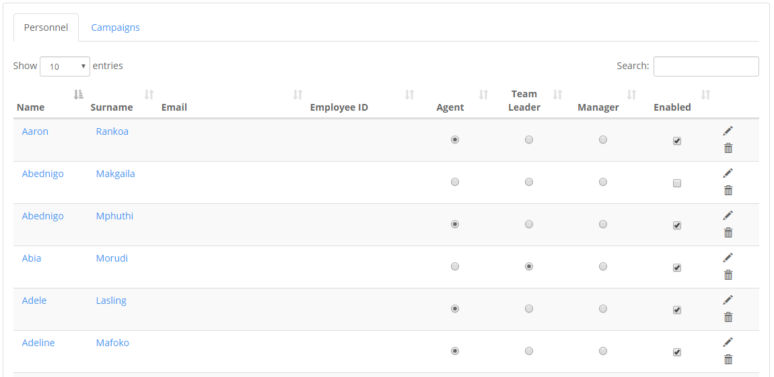

Campaigns View: Shows the basic detail per campaign in a table format including:

1. Campaign ID
2. Campaign Name
3. Number of active persons per role (Agents,Team Leader and Managers)
4. Active lists (Agents,Team Leader and Managers)

Clicking on the campaign name (blue script) or selecting the pencil on the right hand side of the table will allow you to edit the selected campaign. This is adding or removing staff from the selected campaign.

All colomns are sortable using the icon located on the right hand site of the headings on the table.

There is a Search option in the top right hand corner to narrow the entries in the table.

There is also a Show option in the top left hand corner to increase the entries on the table.

This is limited to a selection of 10, 20, 50 or 100 entries.

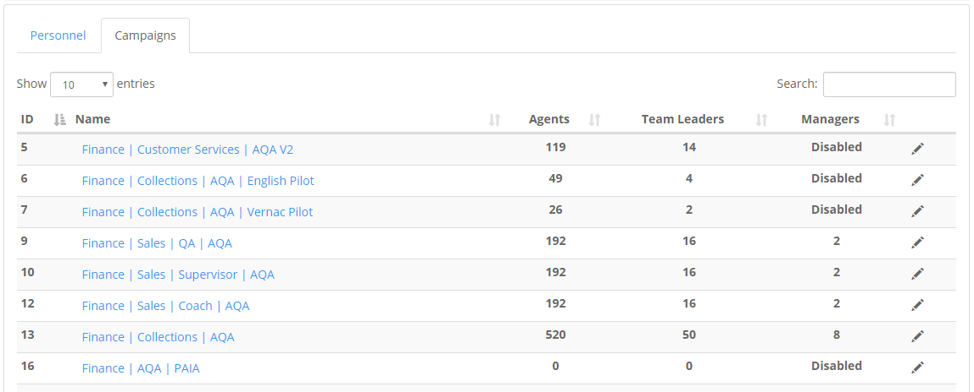



# Add Personnel

Adding personnel can be done in two ways

1. Individual personnel can be added
2. Bulk updates can be done

Both function are accessable using the menu in the Personnel Management





Adding Individual Personnel

Select the Add Personnel button.

A side window will pop-up.

Name and Surname fields are compultory. When they are empty as in the screen shot below, they will be encircled by red to indicate this condition.

The Employee ID is you company’s allocated ID and not the unique id that will be allocated for this system.

Start date can be amended at this point.

However the Last Edit Date is auto populated.

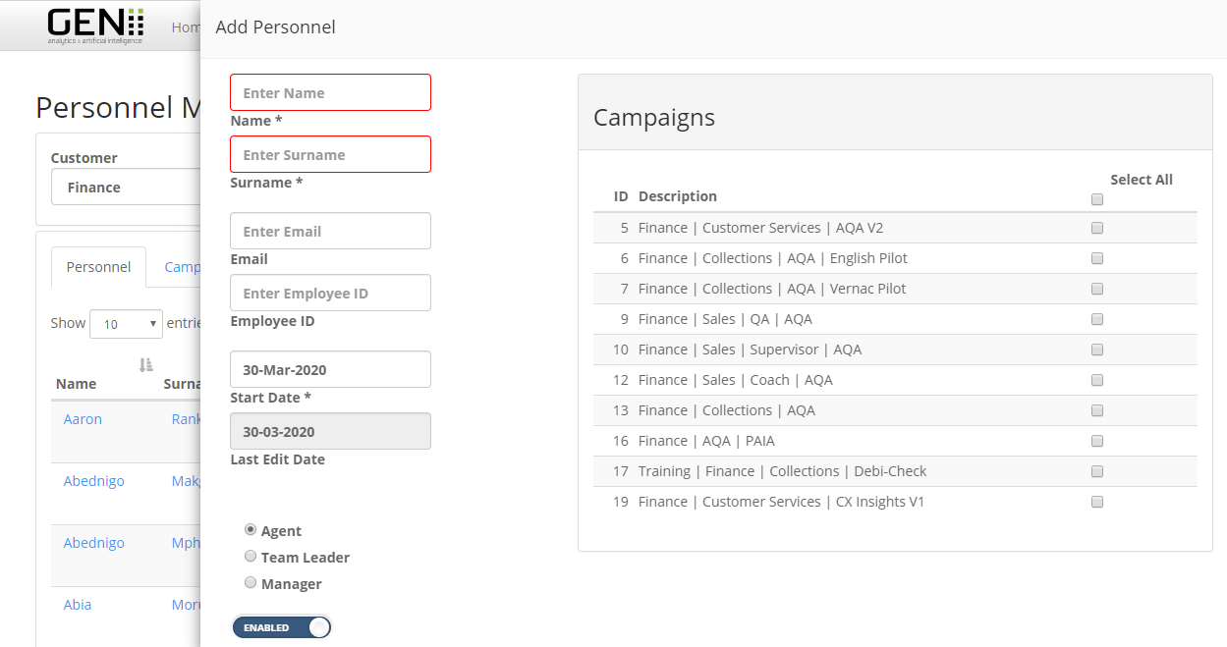

Below is a capture that will not be allowed to save.

Here the red encircled boxes indicate where the errors lie.

I have highlighted in yellow the errors in the example below

1. “é” is not allowed in the Email boxes, but will be allowed in the Name and Surname boxes.
2. “/”is not allowed in the Employee ID box (note hyphen”-“ is allowed)

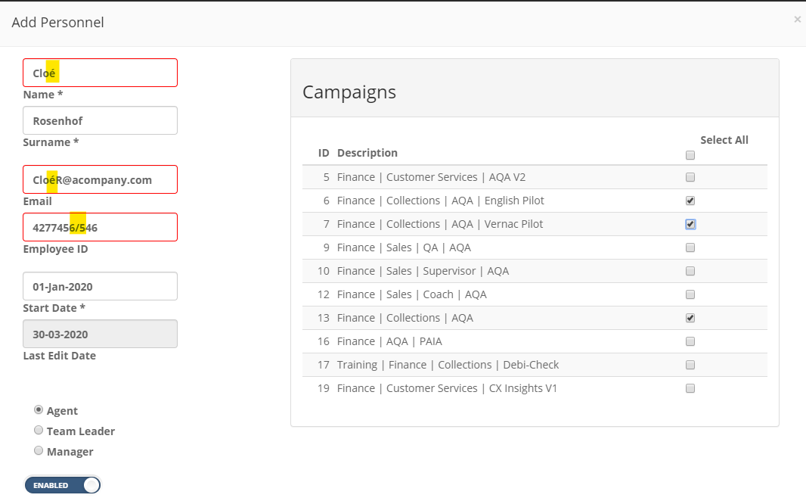



The Save button will also not be available until the errors are corrected.

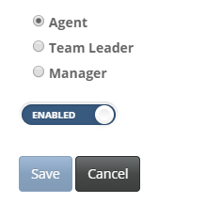

You will be able to update

1. The Start Date
2. The Role (Agent, Team leader or Manager)
3. Enable (on the occasion when you want to do a creation but the person should not be on list immediately)
4. Allocate this person to single or multiple campaigns

Once the errors have been corrected the Save button will enabled.

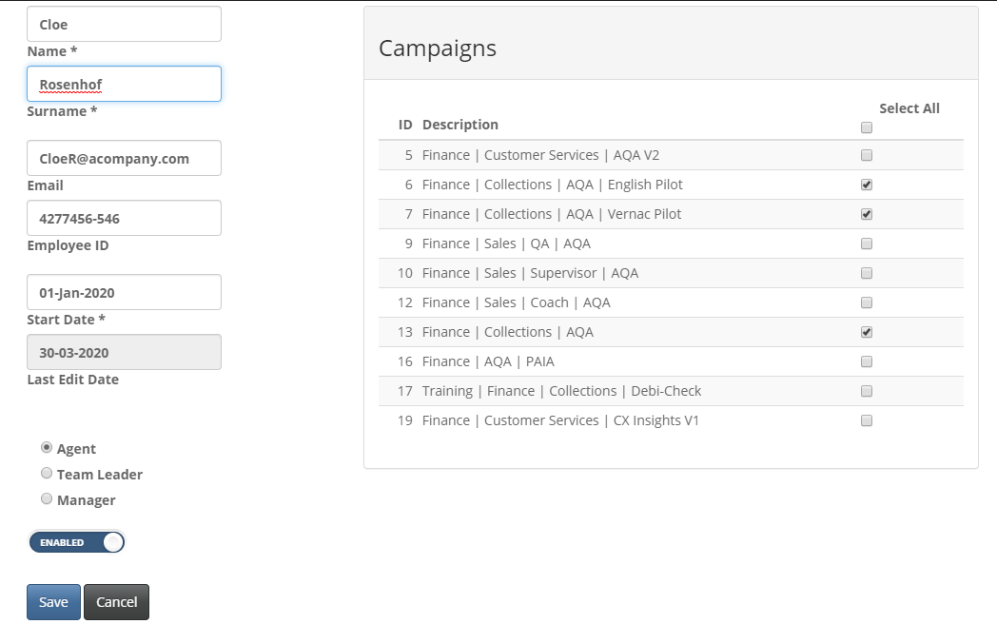

Once saved you will get a notification banner on the main screen and the person will be added to the Personnel table.

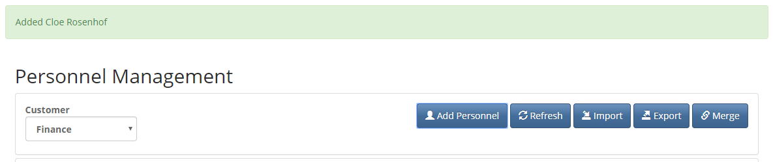

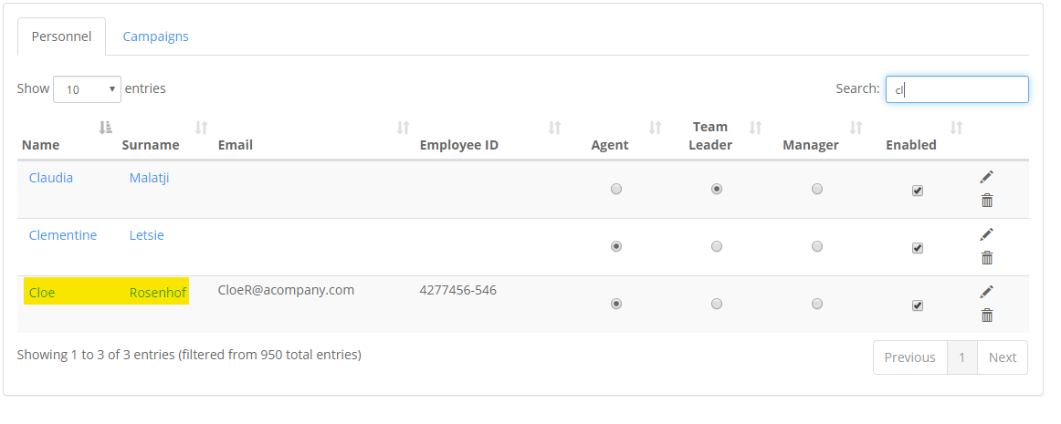

Bulk updates

*adding a group of people*

Ensure that your pc regional settings are set to English (United Kingdom) to ensure that the export displays correctly.

Select the Import button.

The following side window will pop-up.

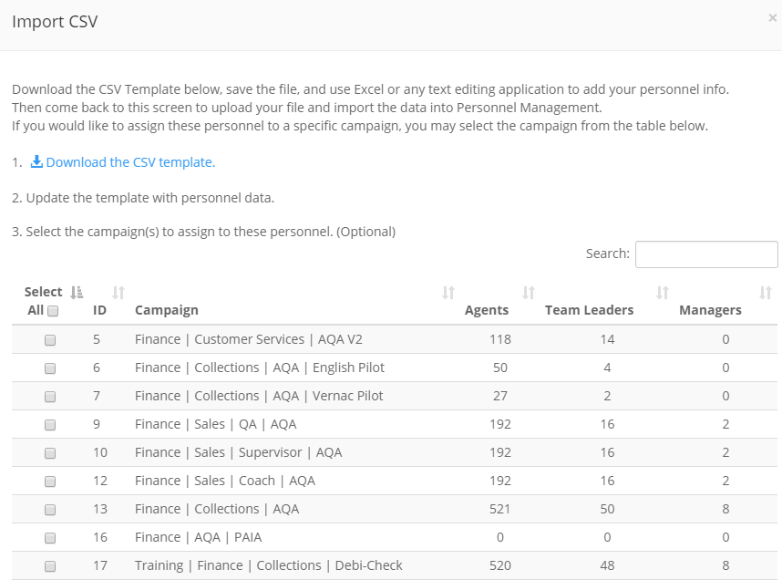

Download and save the CSV template provided (file provided in UTF-8 format).

Save as a CSV UTF-8 (this is to insure that all accent options are saved correctly)

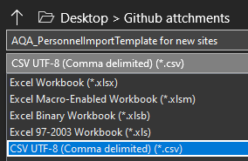

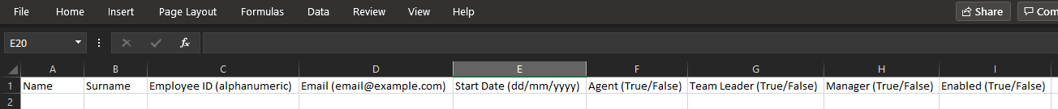

The following coloumns will be found on this template.

1. Name
2. Surname
3. Employee ID (alphanumeric)
4. Email (email@example.com)
5. Start Date (dd/mm/yyyy)
6. Agent (True/False)
7. Team Leader (True/False)
8. Manager (True/False)
9. Enabled (True/False)

The same rules apply to bulk update that are applied to individual updates.

Below is an example of what your file should look like.

Note the error in row A9

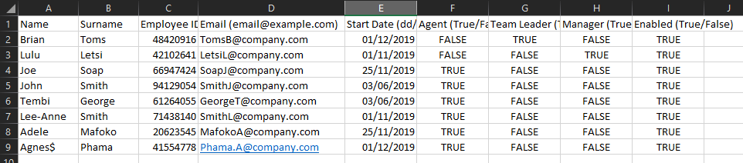

Ensure that you last 4 colounms are correctly filled in.

In the example, your first entry happens to be a team-leader, the second entry is a manager and the rest of the list are agents.

The order you put your staff in doesn’t matter as long as your allocations of TRUE/FALSE are correct.

Once you have saved the file go back to the Import button and scroll down on the side pop-up to Choose File.

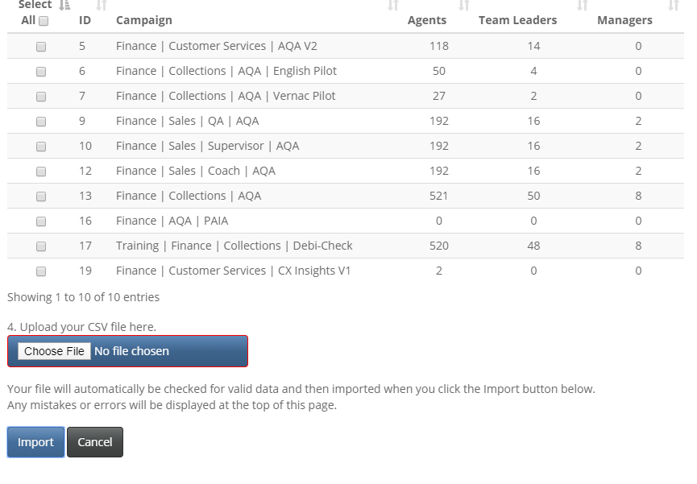

Browse to the location you have saved the file and select Open.

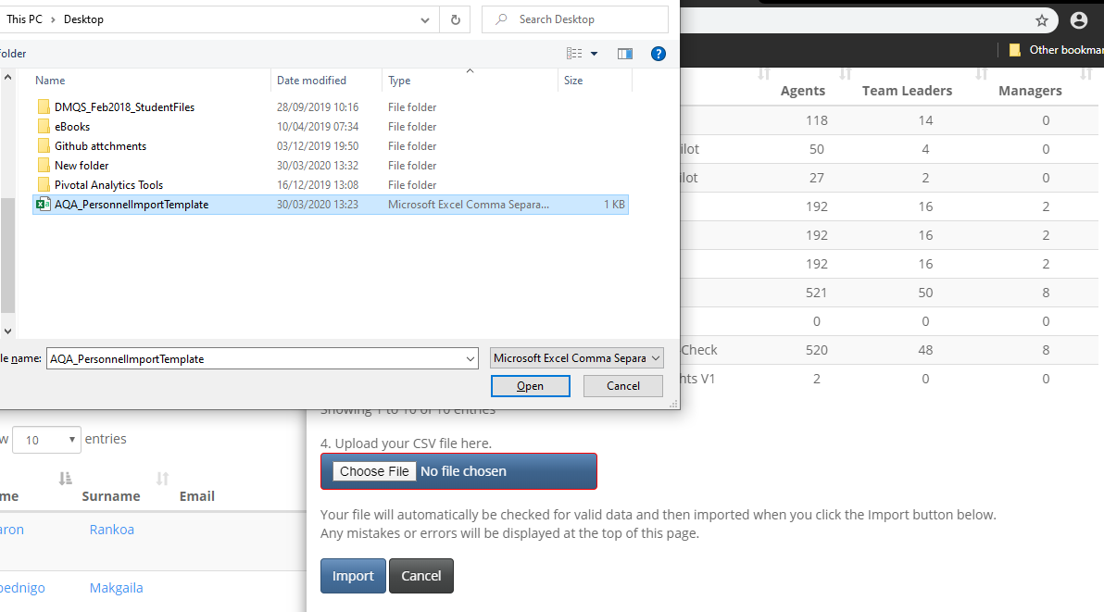

You will see your file name next Choose File

Select Import

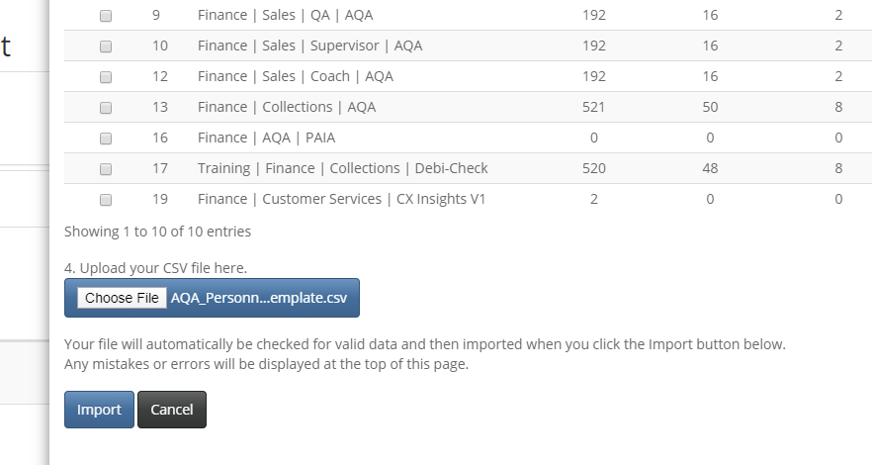



Because of the error we left in A9 you will see the following notification appear at the top of the pop up.

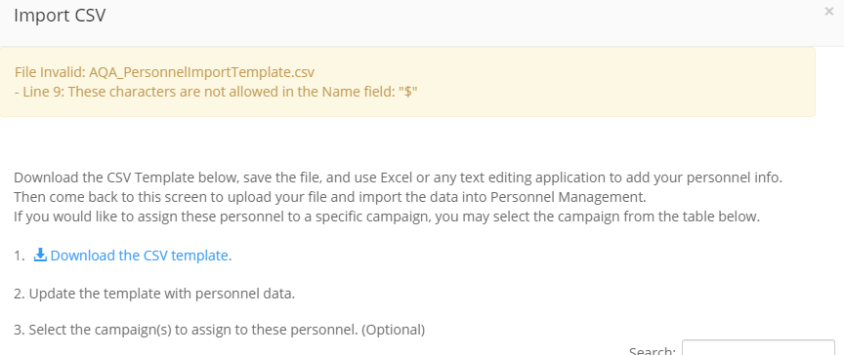

Your file name will also no longer show next to Choose File and the default of No file chosen will show.

So if you see the default of No file chosen, scroll to the top to see what you need to alter.

Once you have corrected and saved the file, you can follow the import option again.

You will get the following notification if you are successful.

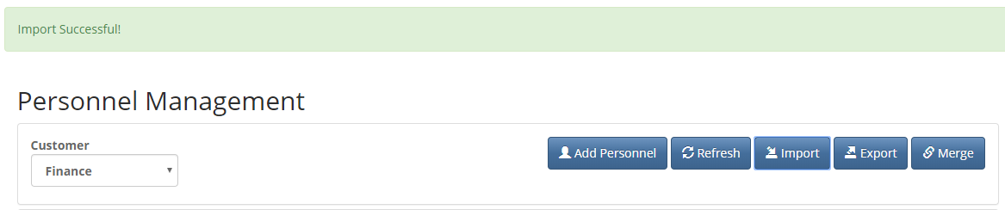

In this example we did not allocate these staff members to campaign.

However, if they are all to be allocated to the same campaign or multiple campaign you can select the applicable campaigns before selecting the import button.

Your staff will now show in the Personnel table view.

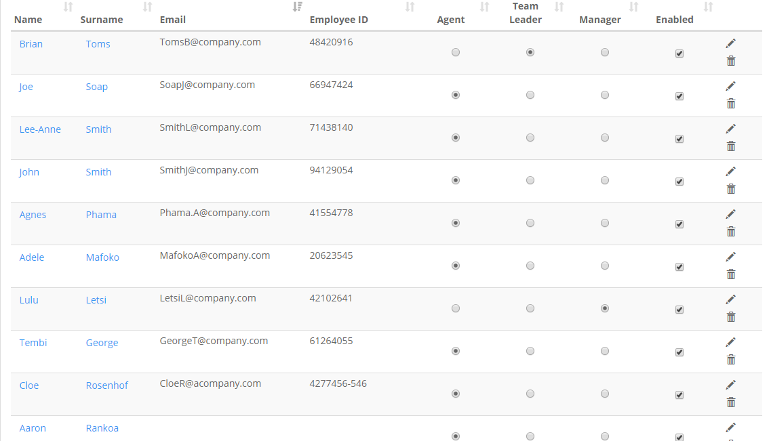

# Export Function

This function will allow you to export personnel information from one or mulitiple campaigns to a CSV file, for review.

Note although the resulting file shares charateristics of the import file you will not be able to use it to make bulk updates / edits, by changing data and then importing the file.

On the personnel menu select Export.





The following side menu will pop-up with the camapaigns assocaited with that customer database.

Note that the Export button is not available and will remain so until you have selected your campaigns.

You can use the search box to narrow down you campaign entry options.

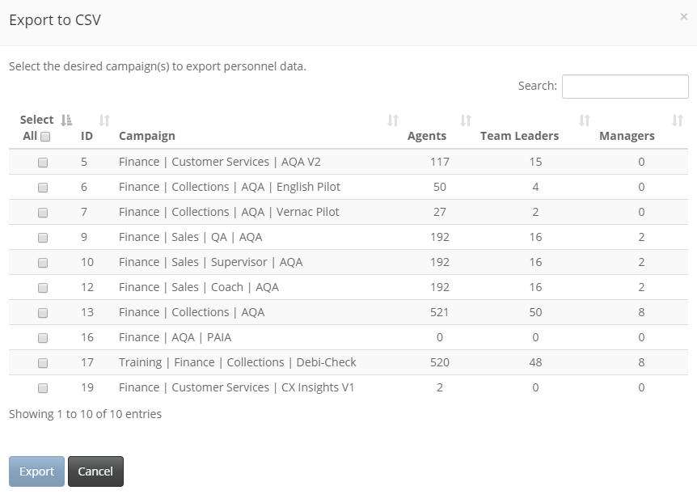



Once you have made your selection, click on the enabled Export button.

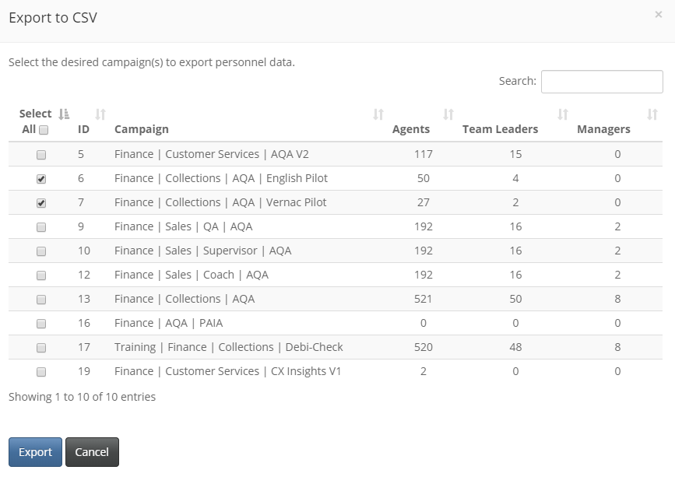



The resulting CSV file will look like this, a filled in verson of the import file with the additional coloum of Unique ID (A).

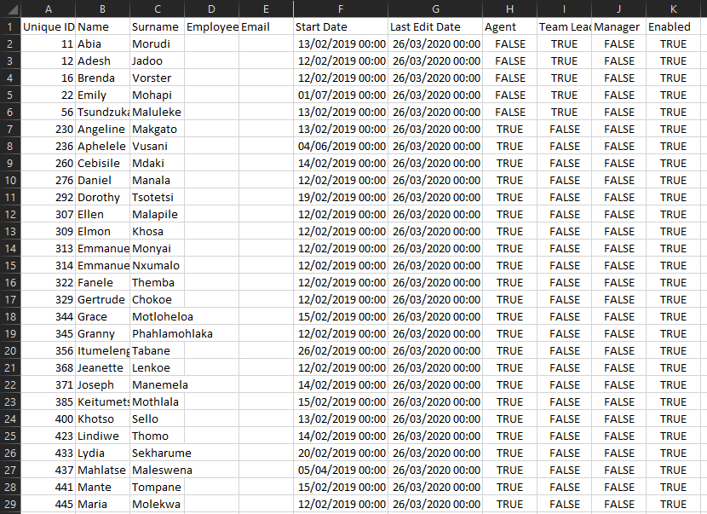

There are a few things to note in this export:

1. This is a consolidated view of both the campaigns I’ve selected. Therefore agents on both campaigns will only show once.
2. No campaign allocations will show here.
3. The list is sorted by Unique ID.

As noted above if you make changes to this file and try to do a bulk update you will get a error notification.

# Merge Function

This function allows you to combine the data of two personnel in the event where one person was created twice.

Example: with the previous list management system, name changes (surname updates) resulted in the data being distributed between the two names depending on the the time of the name update.





Once you have selected Merge, the following following side window will pop-up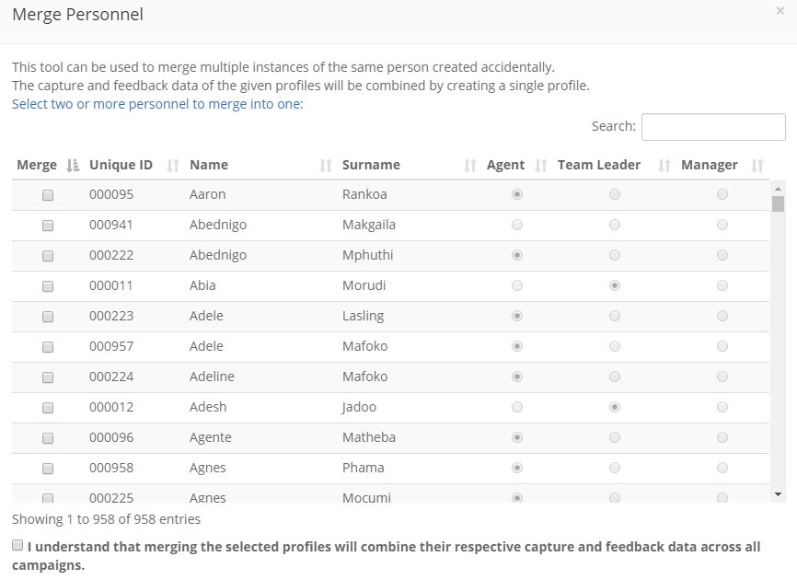



Lets say Mpho got married and wanted her name updated on the app prior to People Manager.

Because we implimented this change she now shows up as 2 separate people on all reports, Mpho Polori and Mpho Ngobeni.

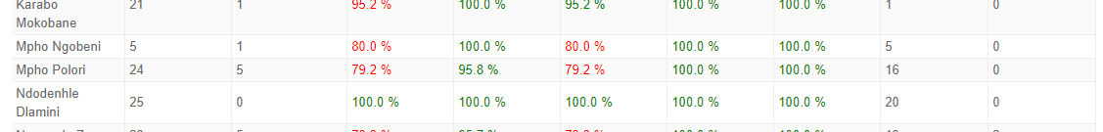

We can now combine the data under one name using the merge function.

We use the search function to reduce the list.

Add ticks to the agents we wish to merge and read the fine print before selecting merge.

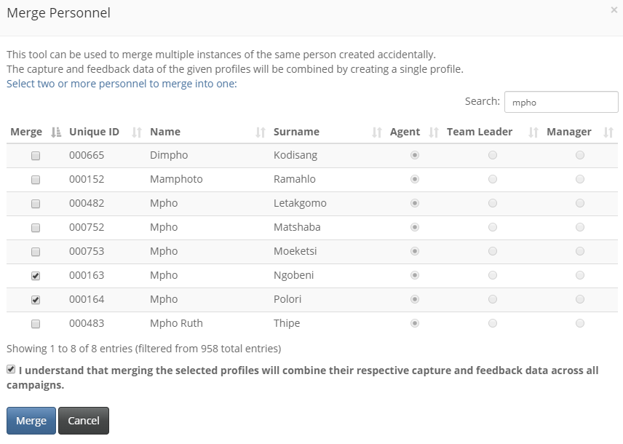



The app will allocated the name associated with the lowest unique id and the following confirmation will appear.

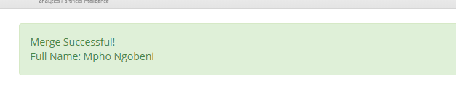

All reports will now show Mpho with a consolidated data set.

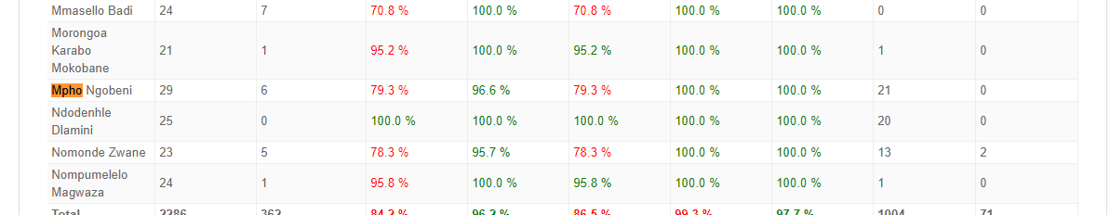

If this is not Mpho’s correct new name, this can be updated using the edit function, detailed below.

# Editing Personnel

You can edit you personnel information by accessing the edit view a few ways.

By clicking the Name, Surname or the pencil icon of the required person you wish to update.

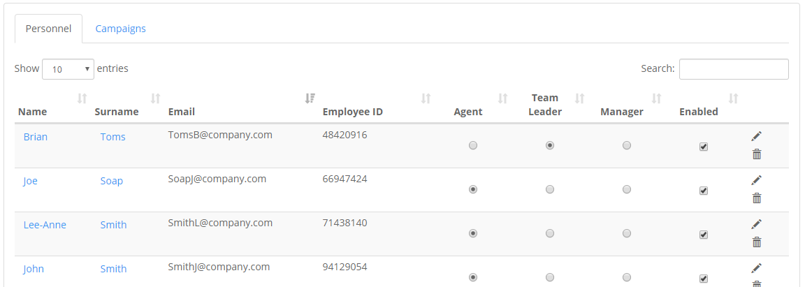



The greyed out areas can’t be changed, however there rest can be updated.

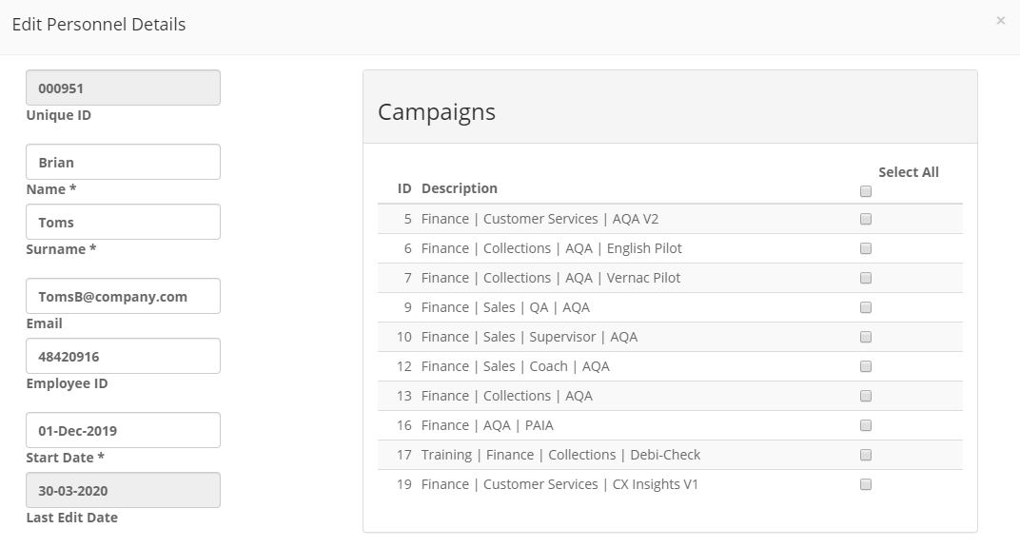



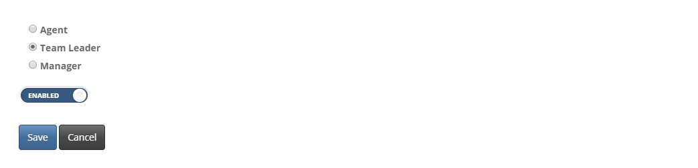

Roles, campaign allocations, spelling mistakes can all be updated in this view.

In this example we are updating Brian’s Surname and Email.

And adding him to the Customer Services Campaign.

You will get a notification once the update is successful.

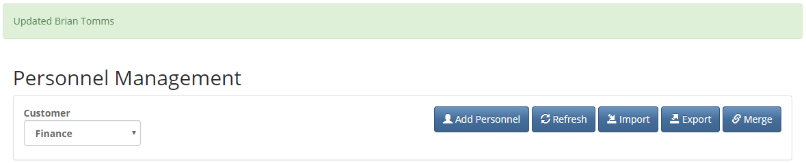

Below is the view the Team Leader list on Customer Services prior to allocated Brian to this campaign.

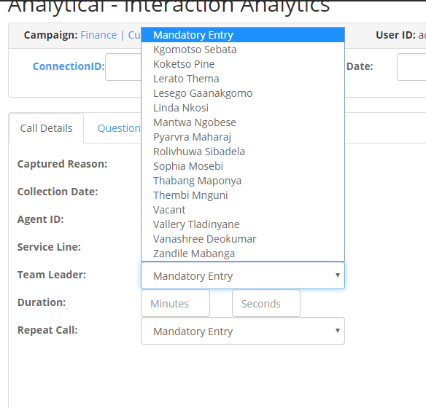

After

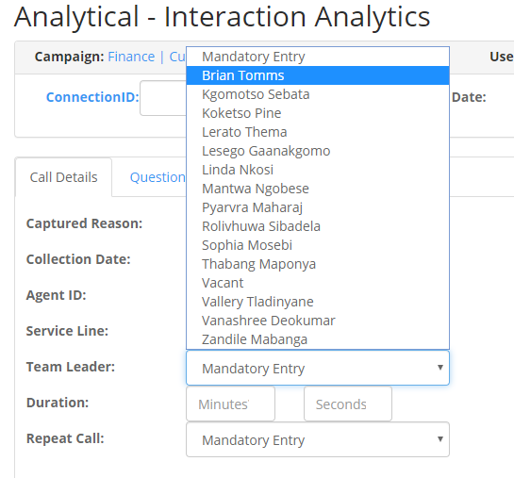

# Removing Personnel from the lists

There are two ways to remove personnel form the lists.

1. Disabling the personnel (Recommended)
2. Deleting the personnel – this can only be done if there is no data linked to this person.

You can do both from the Personnel table view.

Lets remove Fisiwe Thwala from the agent list on Customer Services

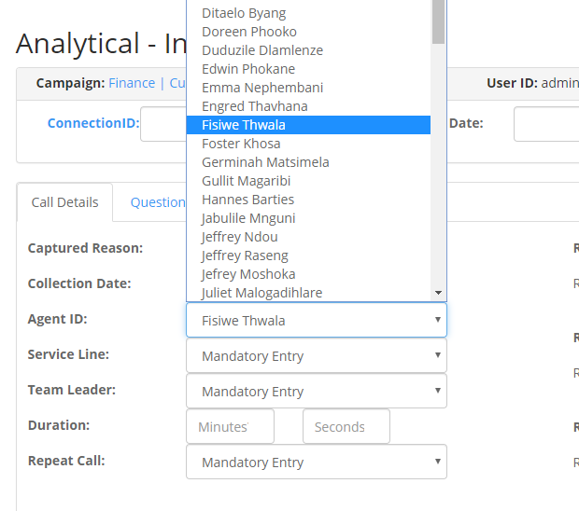

We’ve searched for them using the search function on the Personnel Table.

We can take them off the list by removing the tick in the Enabled coloum.

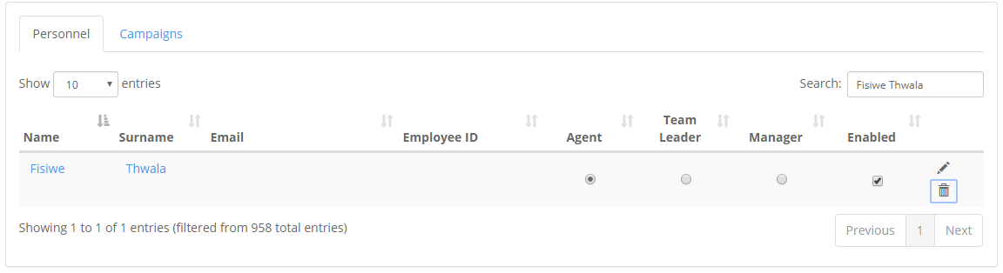

We can also attempt to remove them from the list using the trash can (Remove) icon on the table.

However because this person has captures you will get the following notification

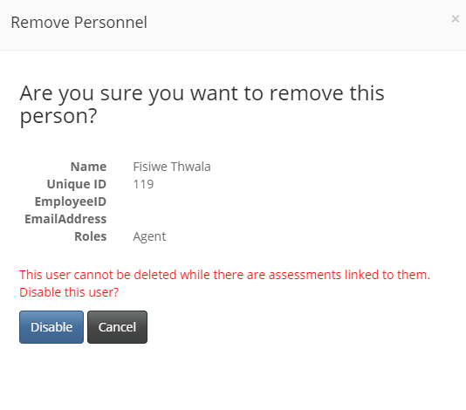

This option will however allow you to Disable the person.

You will be able to view the person on the table, but there will no longer be a tick in the Enabled box and the person will not be on the list.

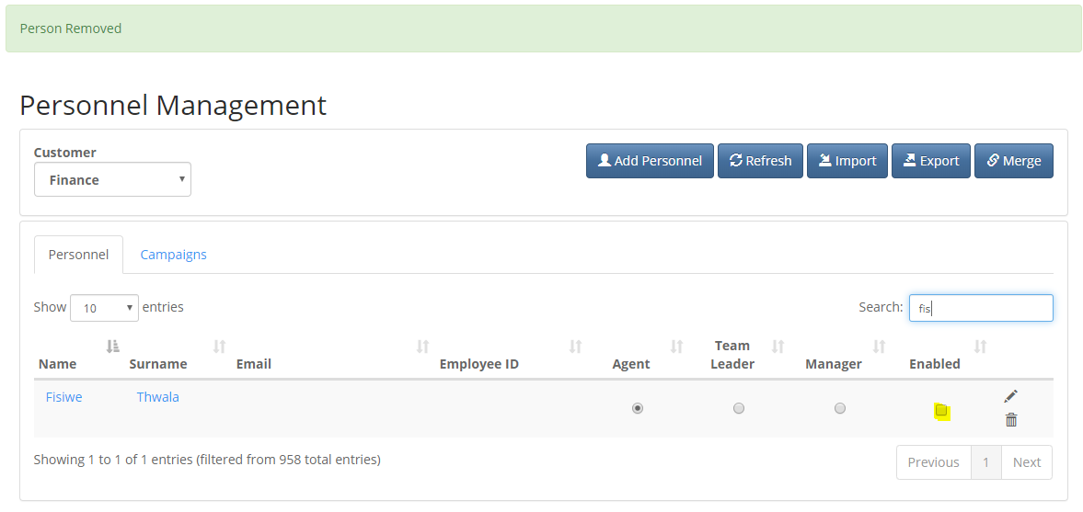

After

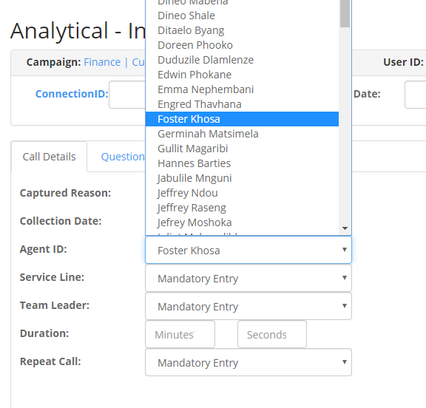

Note: As mentioned previously, this action will updated the list but any data captured will still be viewable on the reports.

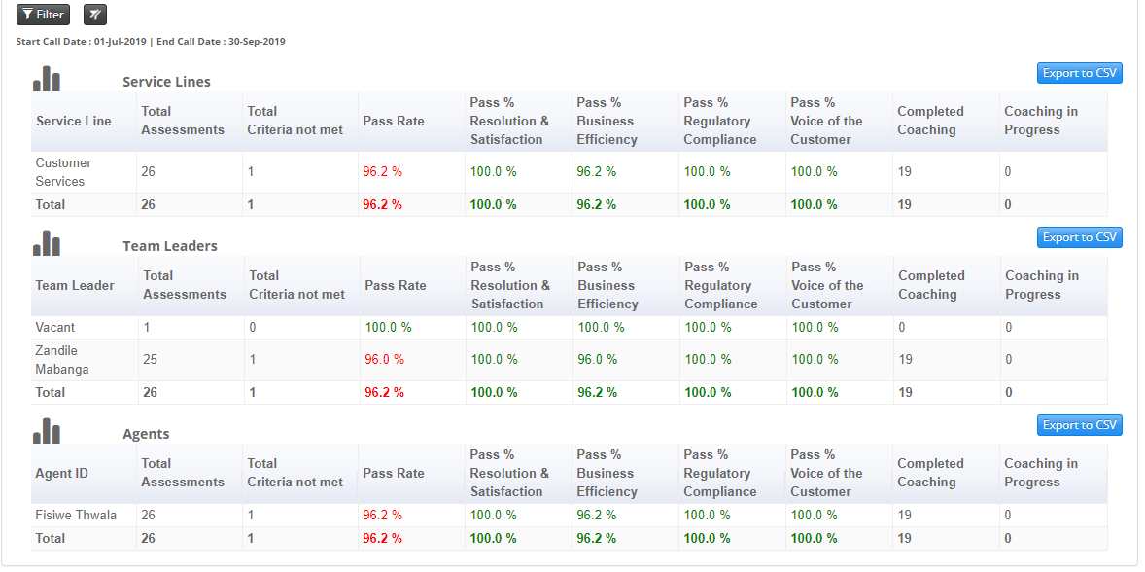

# Allocating Bulk Staff to Campaigns

In the previous chapters, we showed you how to allocate individual existing staff to campaigns using the edit function or adding new staff to campaign with the import function.

Here we will show you how to allocate bulk allocate existing staff to a campaign.

There are a few ways to do this.

* Creating a new campaign
* Transferring / Copying between existing campaigns
* Importing Unique IDs using a .csv import

## Creating a New Campaign

This function is specific to those who can create new campaigns on our app.

When creating new campaigns using existing campaigns, you will now have an option to include or exclude the staff from the existing campaign.

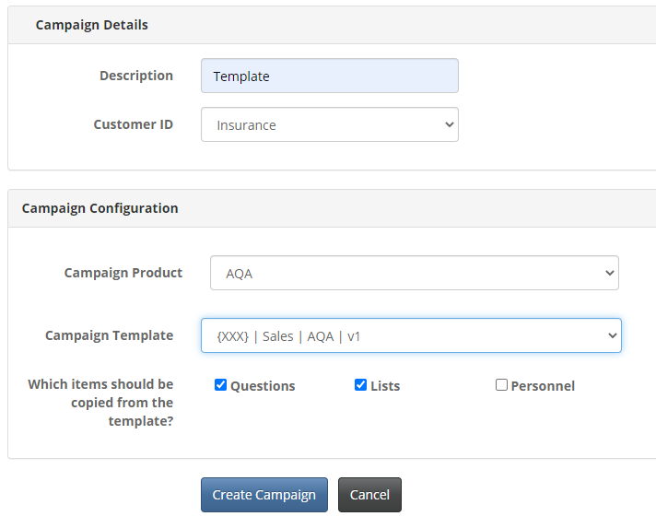

By including a tick in the Personnel box, you will copy all the staff allocated to {XXX} | Sales | AQA | v1 to the new campaign Template.

## Bulk staff allocations between existing campaigns

Here we are going to copy staff to an already existing campaign.

On Personnel Management go to the Campaigns tab.

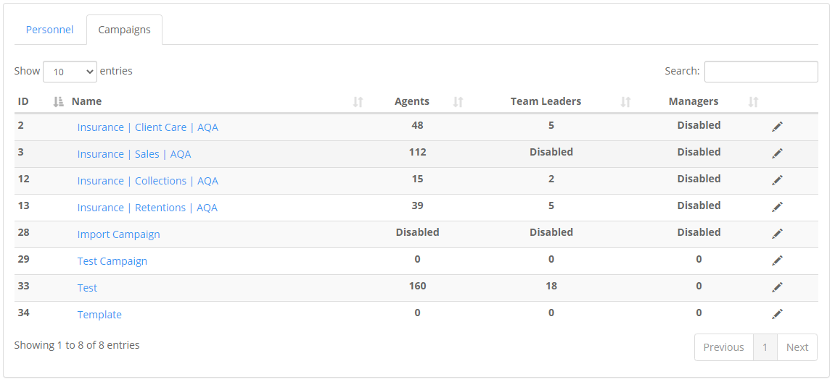

We will be copying staff that are currently on the Collections Campaign to the Template Campaign which has no staff currently.

Click the Template campaign to open the side window.

Click on the button indicated below.

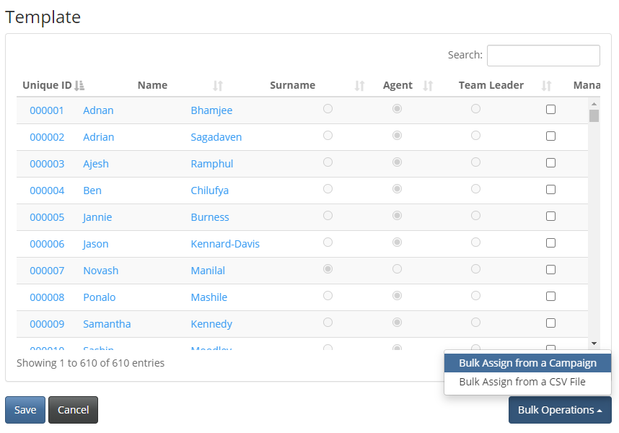

In the new window, select the Collections campaign (you can only select one campaign at a time)

And the click Copy. 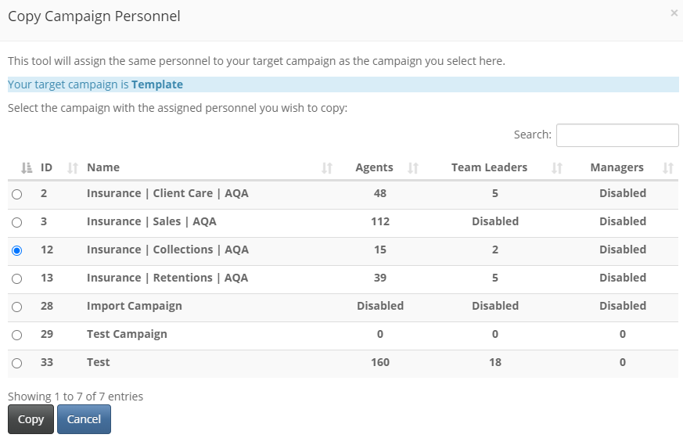

The following message will appear and once you have refreshed the page you will see the numbers update accordingly.

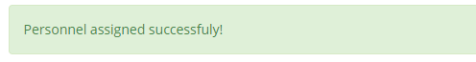

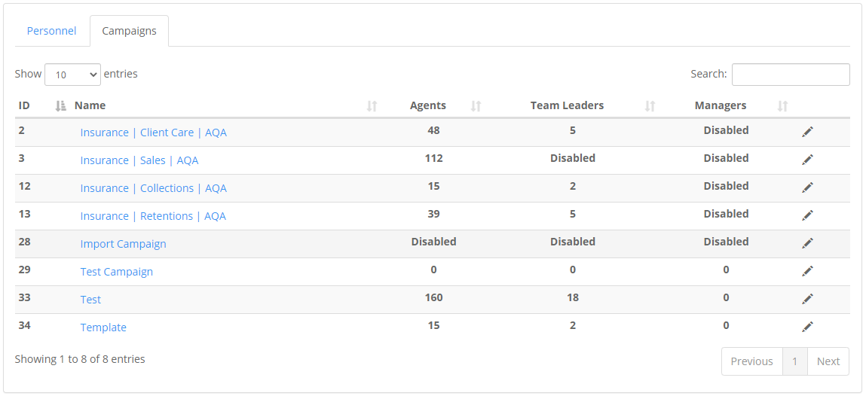

We are now going to add the staff from the Client Care campaign to the Template campaign.

Follow the same process as above.

You will now see that because we already have staff on the Template campaign you will be given an option to either keep or replace the existing staff.

We will be adding to the staff compliment.

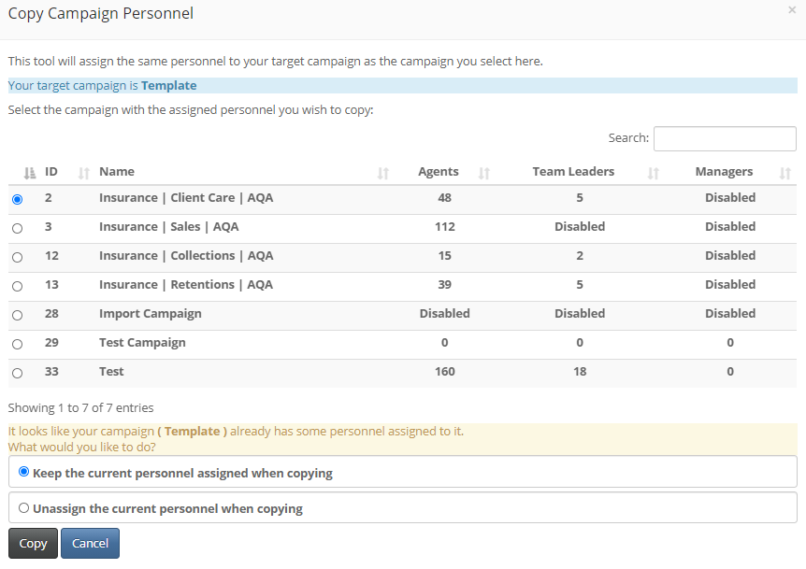



The Template campaign will now have a combination of the staff from both the Collections and Client Care campaigns.

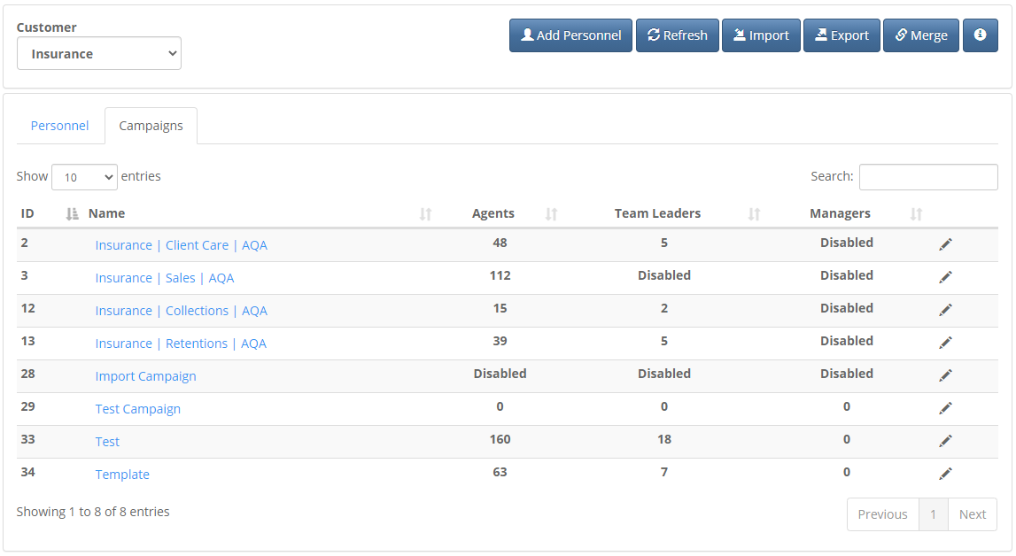

Please note that this copy function will not work across client dbs.

You will only be able to assign staff between campaigns on the same client db.

## Bulk allocations using a .csv import

This function allows you to manage your staff allocations using a .csv file.

It should be noted that you can not add staff or change any staff detail using this functionality.

It will only manage existing staff allocation to a specific campaign.

You will need to have the unique id of your staff to use this function.

To get that information, you will use the Export function on Personnel Manager.



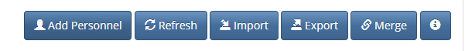

Once you click Export, the following window will pop out.

If you are not sure on which campaign the required agent is situated, you can Select All as in the screen shot below.

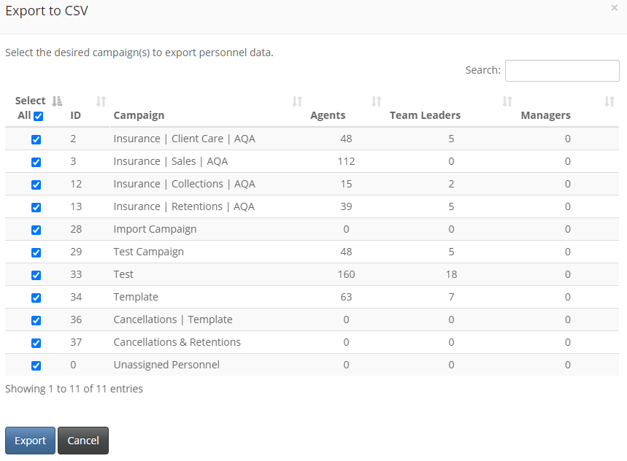

You will see that you can now also select personnel not allocated to a given campaign -*Unassigned Personnel.*

Once you have clicked on Export, you will get a .csv download like the one below.

Search for the ids of the personnel you want allocated to the new campaign.

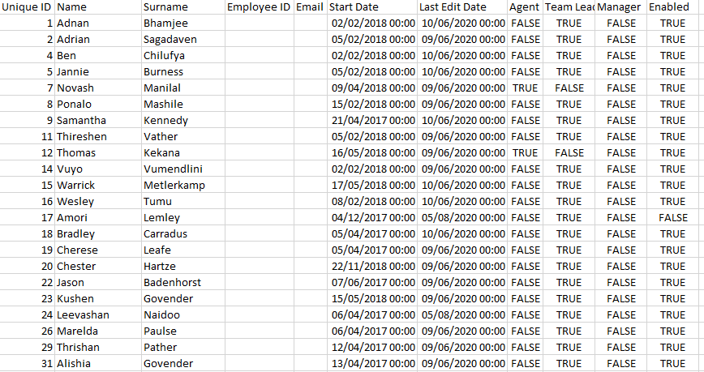

Now go to the Campaigns tab and select the campaign you wish to update.

 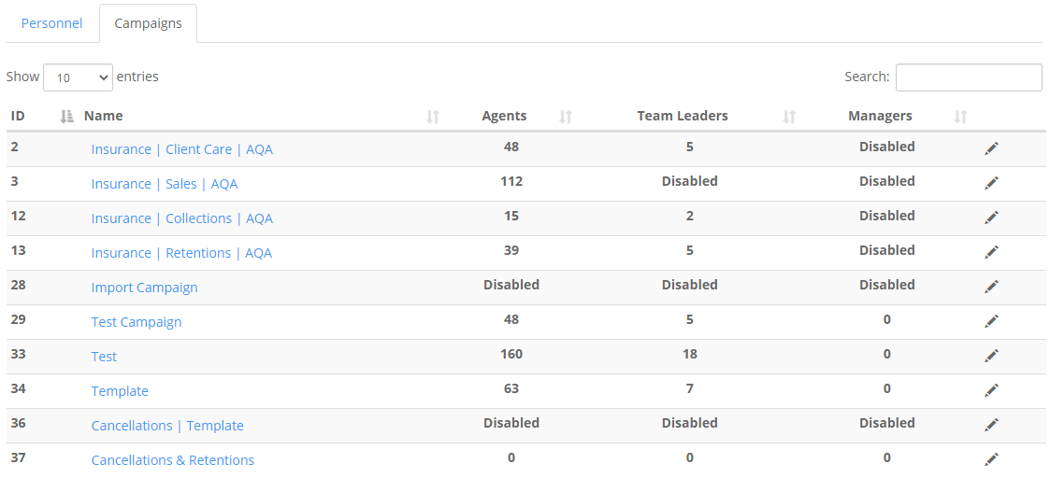

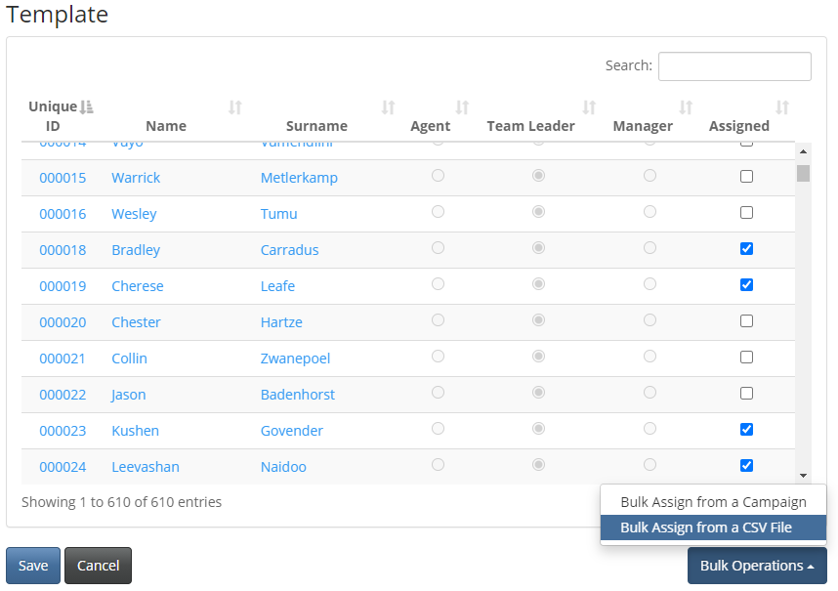

Select the *Bulk Assign from a CSV File* and the following window will pop out.

Download the assigned personnel csv.

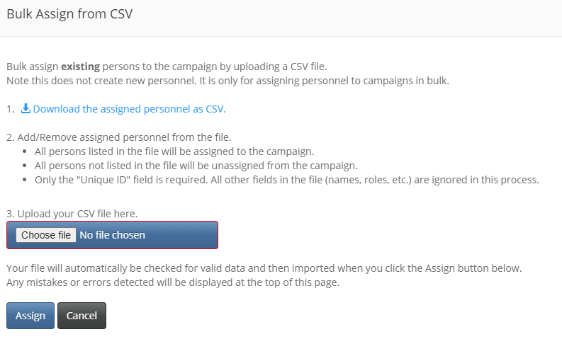

You will get a campaign specific csv like the previous export.

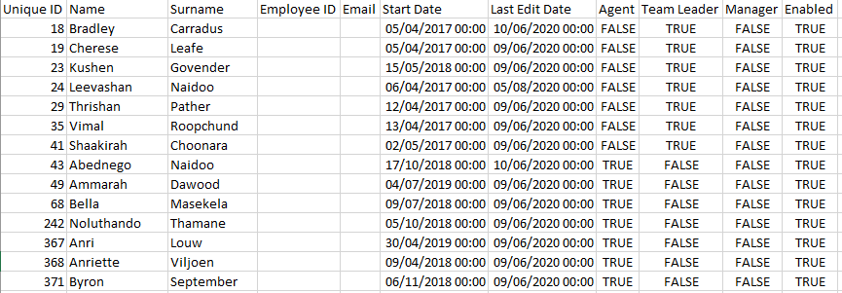

Scroll down to the bottom of this download and add the users you want allocated to the campaign. Note only the id are required, other detail will be ignored.

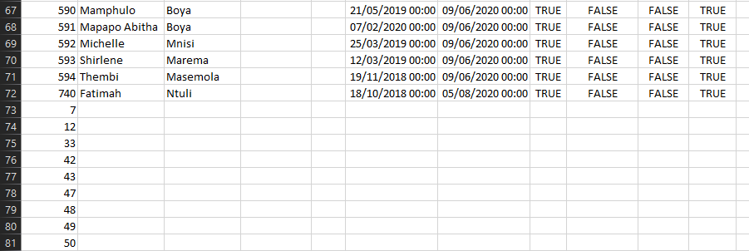

You can also remove any rows where you want to unassign from the campaign.

Save your file.

Note: that I have added user id 43 and 49 to the campaign even though they are already allocated to the campaign. We will come back to this later.

Now go back to the bulk assign window on the app.

Select *Choose File* and browse to your saved updated file and select it.

Click *Assign*.

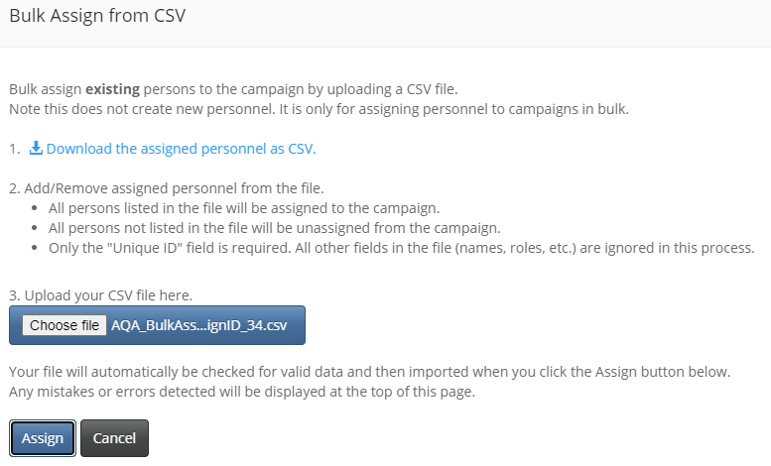

You will get the following notification and after you have used the *Refresh* button your campaign numbers will be updated.

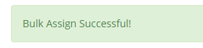

You will get the following type of notification if you have an error on your file.

All valid personnel will be allocated.

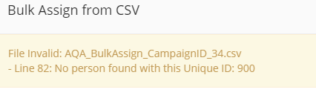

Original agent count = 63



I added 9 additional personnel, of which 2 where already assigned to the campaign (id 43 & 49) as mentioned earlier.

The system has recognised this and allocated the 7 unique ids to the campaign, leaving you with a new total of 70 agents.

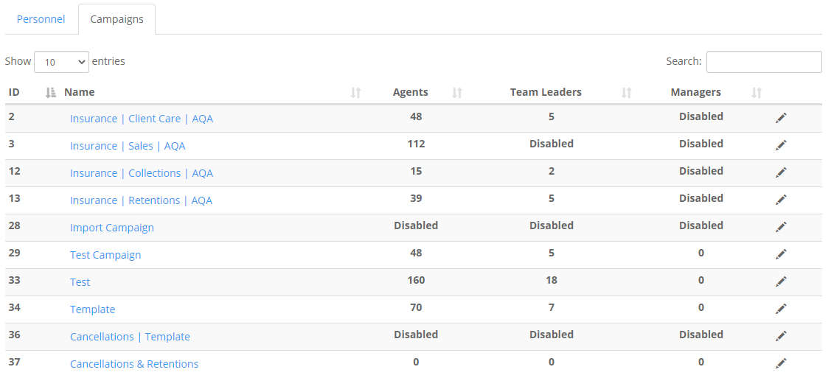

FIN